AWS LANDING ZONE DEPLOYMENT USING TERRAFORM

PURPOSE OF THE DOCUMENT:

This document contains the overview of set up of landing zone using control tower and creation of organizational units and accounts under it.Using AFT (Account Factory for Terraform) to customize and provision the accounts under the organization.

PROJECT OBJECTIVE:

Using AWS Control Tower and Terraform, the project will construct a standardized AWS Landing Zone infrastructure with an emphasis on networking, security, and effective account administration. To demonstrate effective infrastructure provisioning, thorough documentation is essential. This includes Terraform configuration files, network diagrams, IAM Policies, and deployment logs. In order to implement policies, the organizational structure entails the construction of Organizational Units (OUs) such as Log, Security, Prod, and Non-Prod, in addition to Service Control Policies. Best practices for network security should be incorporated into the design of the VPC architecture, and consistency is guaranteed by automatic account provisioning via AWS Control Tower's Account Factory. Important elements include AWS CloudTrail logging configurations, IAM role and permission management, secret management techniques, and compliance monitoring. The project necessitates a careful methodology that makes use of both AWS Control Tower and Terraform to establish a secure and standardized AWS environment.

TOOLS REQUIRED:

AWS CLI
Terraform

FOLDER STRUCTURE:
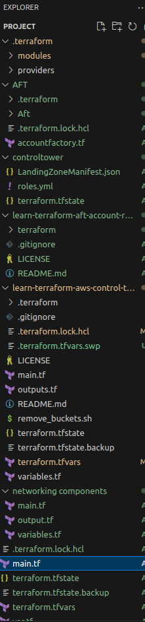

CONTROL TOWER SET UP USING TERRAFORM:

STEP 1 : Create a VPC with 2 private subnets and 2 public subnets using terraform by specifiying the variable names ,availability zone,route table associated,NAT gateway and Internet gateway.

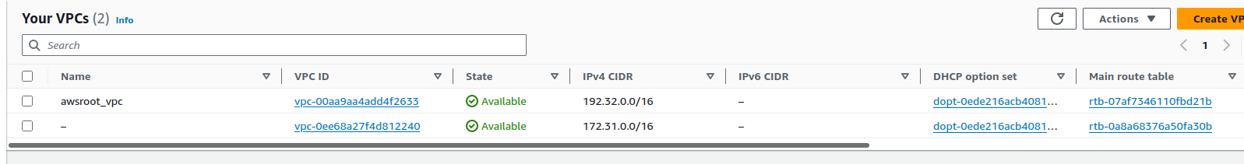

STEP 2 : Create a module for the networking components.
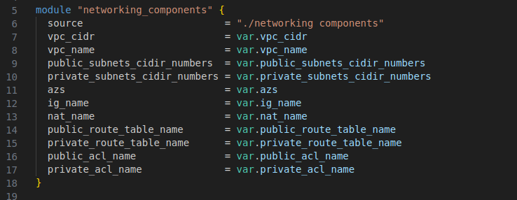

STEP 3: Call the AWS Organizations CreateOrganization API and enable all features to create the Foundational OU. AWS Control Tower initially names this the Security OU. This Security OU contains your two shared accounts, which by default are called the log archive account and the audit account.
aws organizations create-organization --feature-set ALL
STEP 4: To set up your landing zone, AWS Control Tower requires two email addresses. If you are using landing zone APIs to set up AWS Control Tower for the first time, you must use existing security and log archive AWS accounts. You can use the current email addresses of the existing AWS accounts. Each of these email addresses will serve as a collaborative inbox -- a shared email account -- intended for the various users in your enterprise that will do specific work related to AWS Control Tower.

aws organizations create-account --email kavya@1cloudhub.com --account-name "Logging Account"

aws organizations create-account --email kavya+1@1cloudhub.com --account-name "Audit Account"

STEP 5: Specify the roles and policies that is needed to be attached to set up the landing zone after the control tower is enabled.
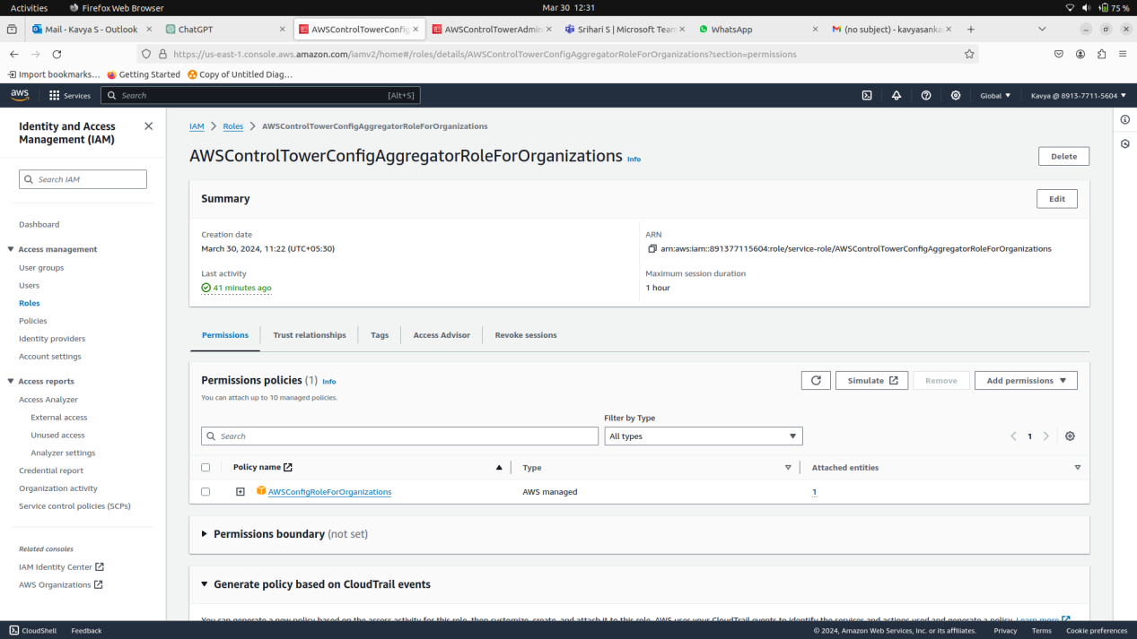

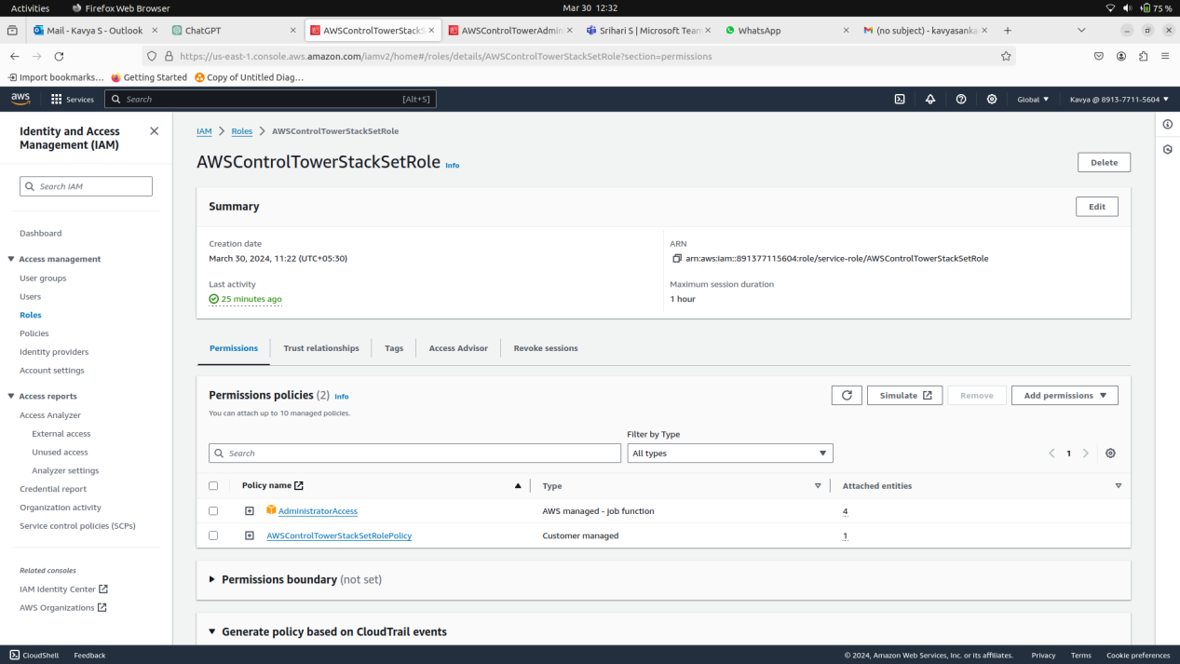

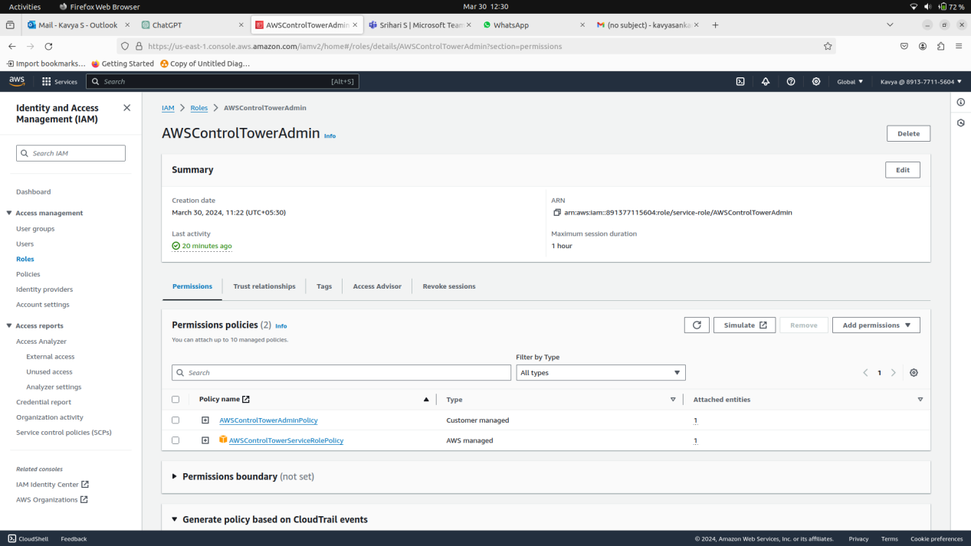

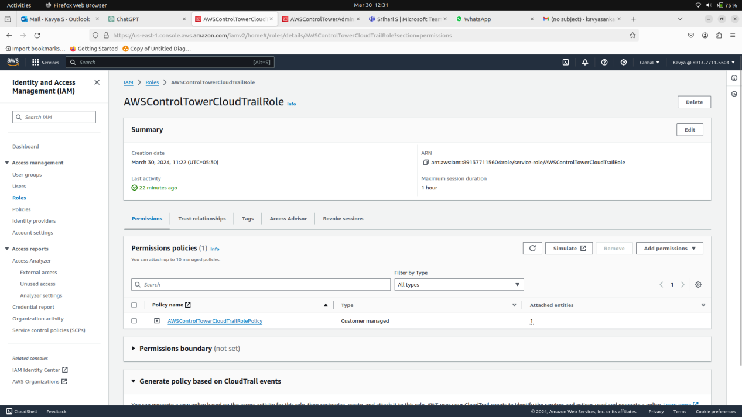

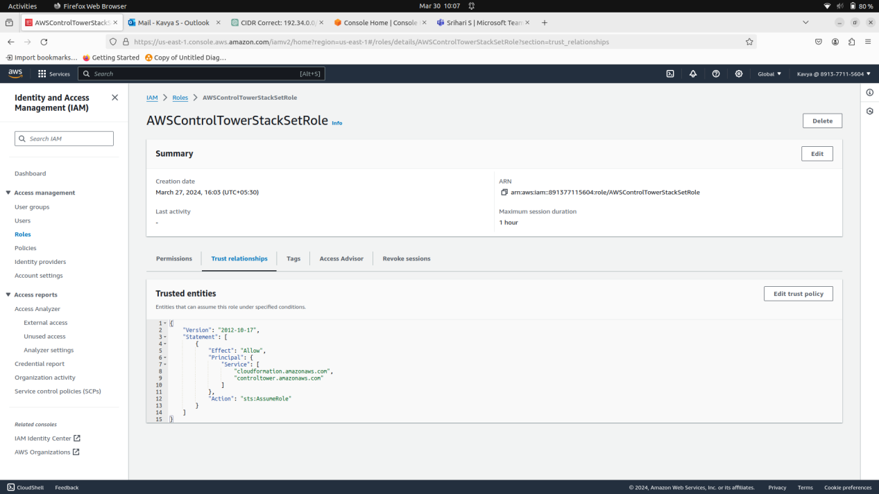

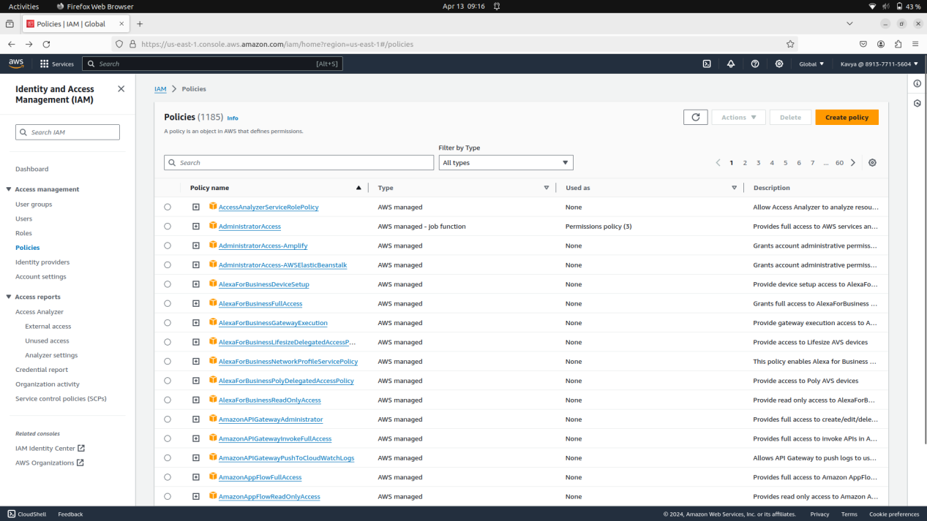
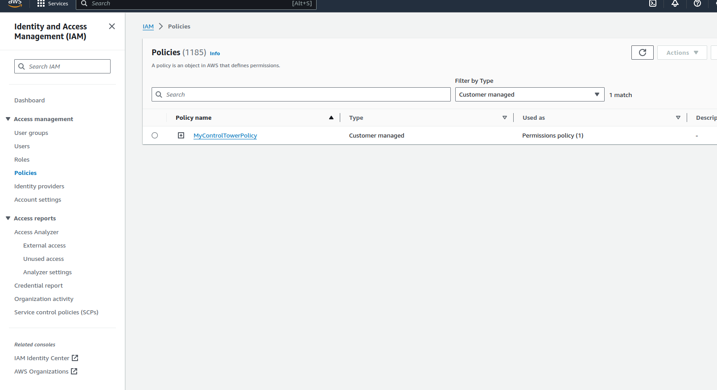

STEP 6: Write up the code for the roles and policies in yaml format as a cloud formation stackset and create it using the below command.

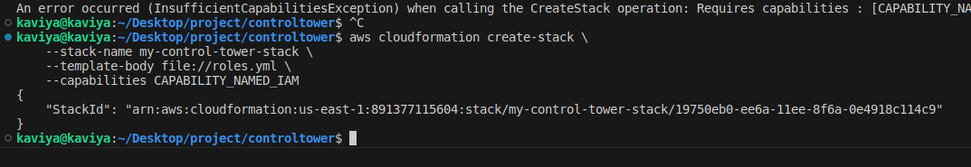

STEP 7: Write a landing zone manifest json file by specifying the id of the accounts.
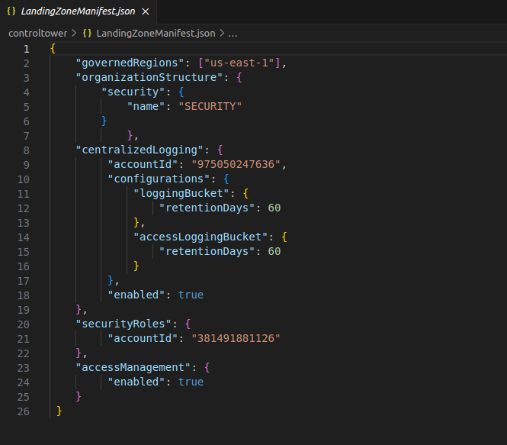

STEP 8: Set up the control tower by using the module from the terraform registry.

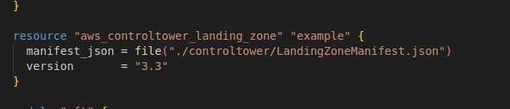

STEP 9: Do the following actions to set up the landing zone using AWS Control tower
Terraform init
Terraform plan
Terraform apply
STEP 10:The landing zone will be set up and it takes upto 60 minutes.
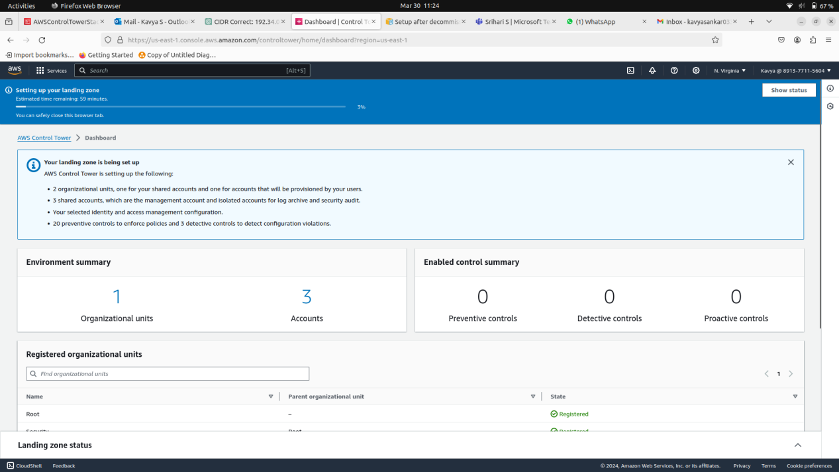

STEP 11:Once the landing zone is setup the necessary Service control policies and guardrails will be set up.

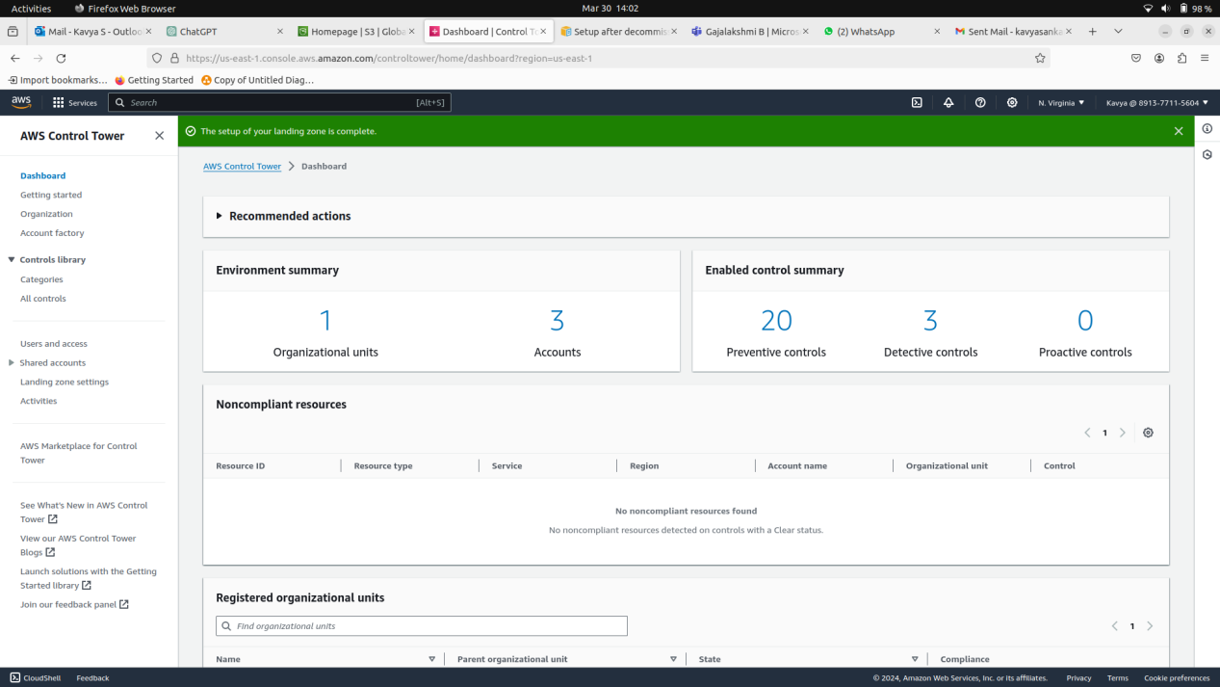

STEP 12: Once the landing zone is set up with Security OU under which 2 accounts namely the log and the audit account. Using Account Factory for terraform 2 OU ‘s and accounts under it namely the production and the non production is to be set up.

ACCOUNT FACTORY FOR TERRAFORM WORK FLOW
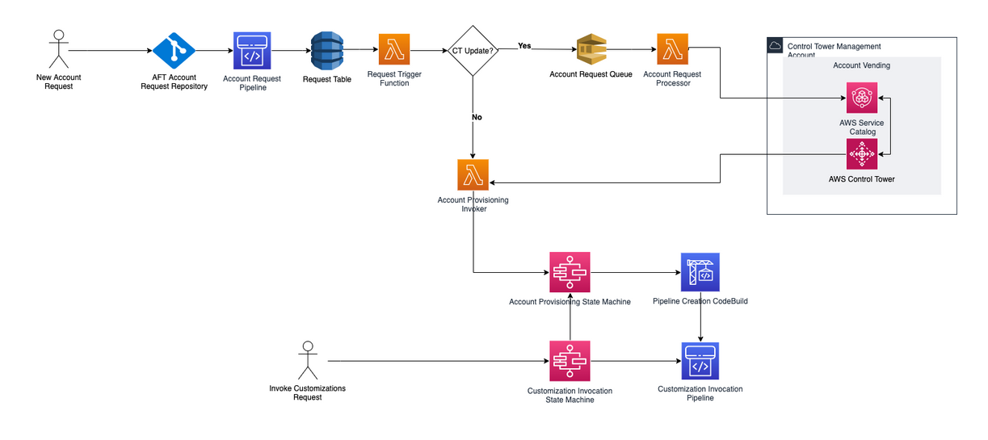

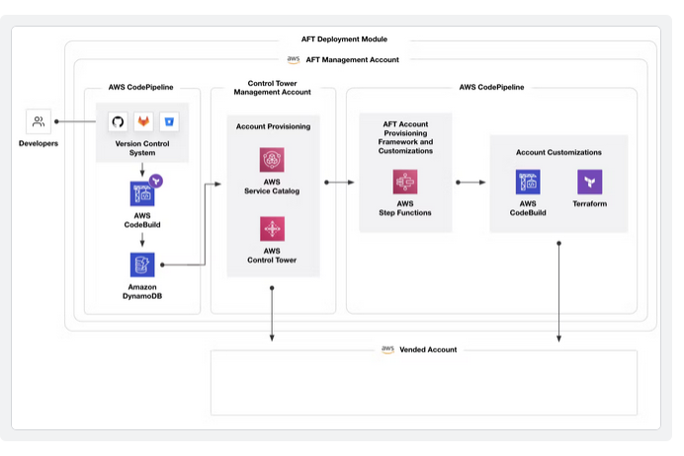

STEP 13:In the AWS dashboard, navigate to ControlTower, then select Organizational Units (OU) in the left sidebar. Click Add an OU to create a new organizational unit for AFT.
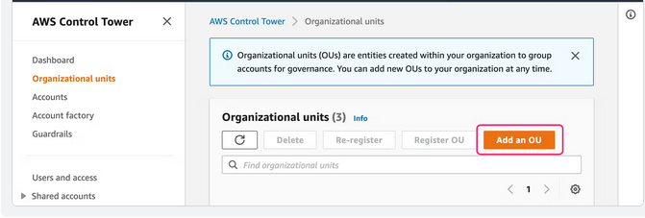

STEP 14: Name the OU and select your Root OU as the parent OU, then click Add.
STEP 15: Once your new OU is ready, navigate to Account Factory in the left sidebar, then click Enroll Account.
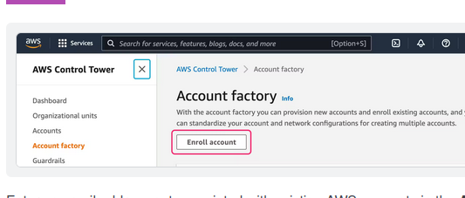
STEP 16: Enter an email address not associated with existing AWS accounts in the Account email field. This will be the account's root email address. Enter the display name; enter an email address you have access to for the SSO email, and enter the AWS SSO user’s first and last name. Then, the Parent OU. Finally, click Enroll Account.
STEP 17: It requires 4 repositories which need to be forked from the github provided by the AWS documentation.
- The learn-terraform-aft-account-request repository, which contains example configuration to kick off new account provisioning using AFT.
- The learn-terraform-aft-global-customizations repository, which contains boilerplate configuration for customizations to apply to all accounts created by AFT.
- The learn-terraform-aft-account-customizations repository, which contains boilerplate configuration for account-specific customizations.
- The learn-terraform-aft-account-provisioning-customizations repository, which contains boilerplate configuration for provisioning-time customizations to apply to accounts.

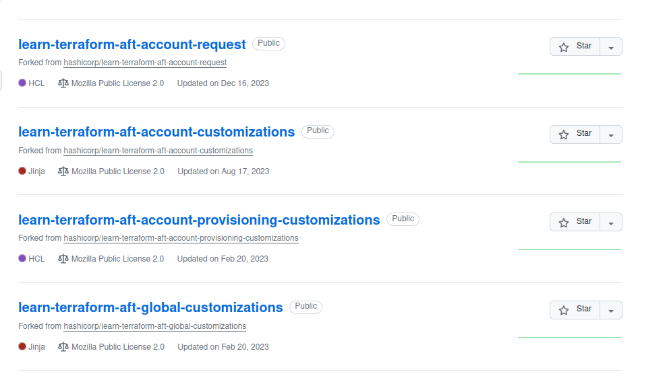
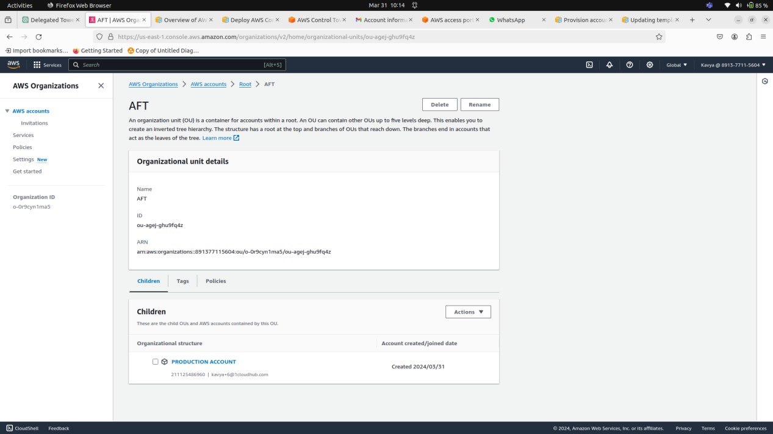
STEP 18: The AWS team maintains the control_tower_account_factory Terraform module . This module defines a pipeline of AWS services that allow you to provision and customize accounts in Control Tower.
git clone https://github.com/hashicorp/learn-terraform-aws-control-tower-aft
STEP 19: In your terminal, navigate to the learn-terraform-aws-control-tower-aft repository cloned earlier.

cd learn-terraform-aws-control-tower-aft

STEP 20:Open the main.tf and specify the required values.

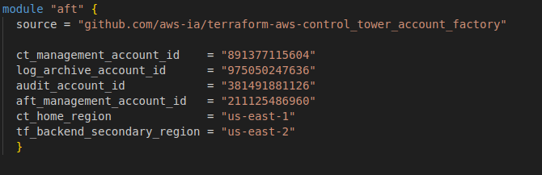

STEP 21: Go to the developer settings and enable the pending action.
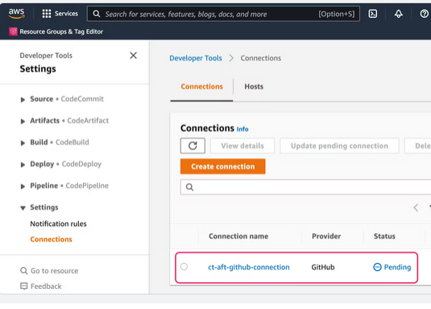
STEP 22: Create an connection to the github.
STEP 23: Go to the service catalog and ensure the permission settings.
By clicking the portfolio and going to the AWS Control Tower account factory portfolio and check on the roles,groups and users that is to be enabled. Add AWSAFTEXECUTION to it.
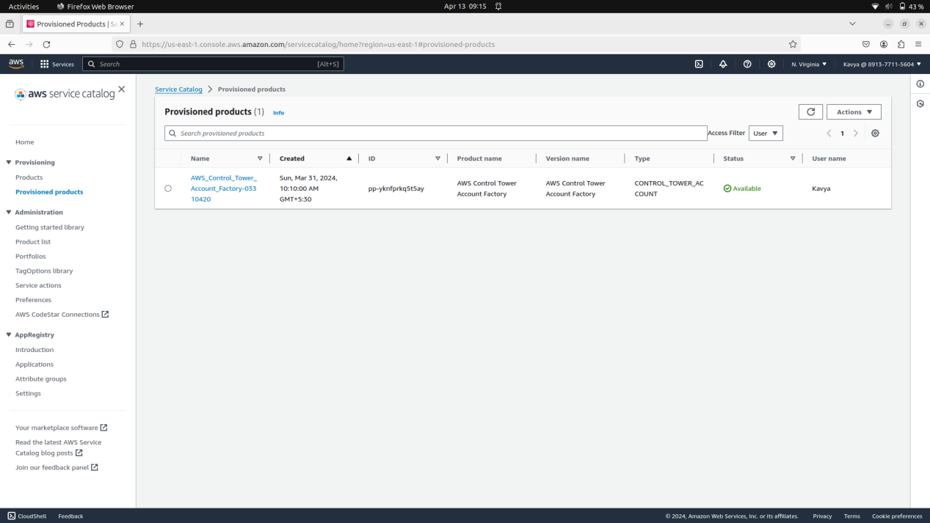
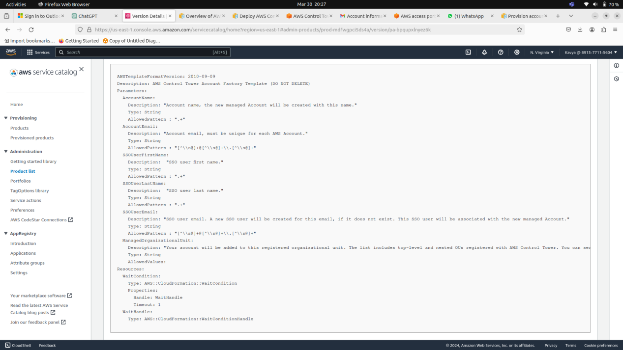

STEP 24:Set up the production and non production account by specifying the necessary account email the control tower parameters and account tags.
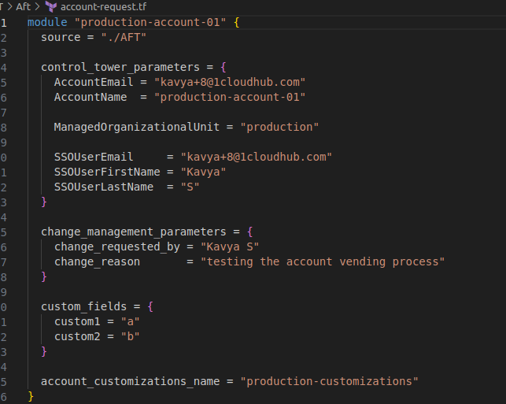
The accounts under the Organizational units can be opened using the IAM USER link in the IAM IDENTITY CENTRE.
Enable the MFA (Multi Factor Authentication) for this.
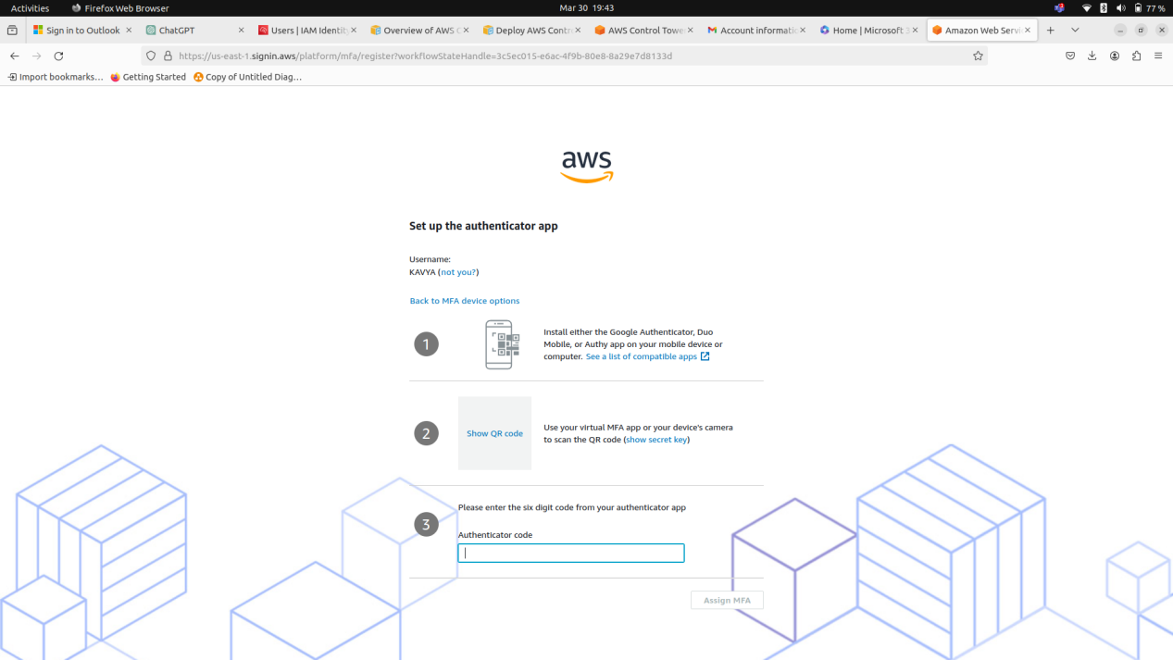

Install the Google Authenticator App in the mobile ,scan the QR and enter the authenticar code mentioned.
STEP 25: After specifying it use the terraform apply command.
The Organizational units and the accounts under it will be created.
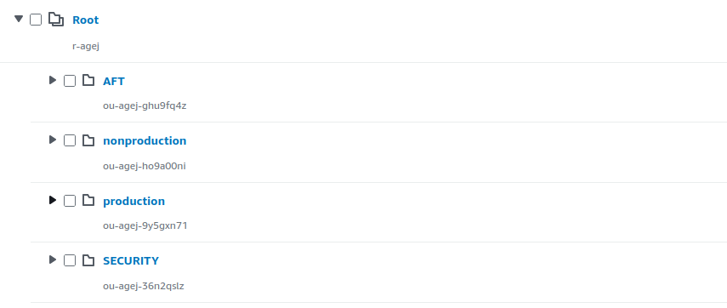
STEP 26:After completion of the entire process use the terraform destroy command to completely destroy it.
The landing zone will be decommissioned and the some manual clean up process need to be done to ensure successful decommissioning of landing zone.
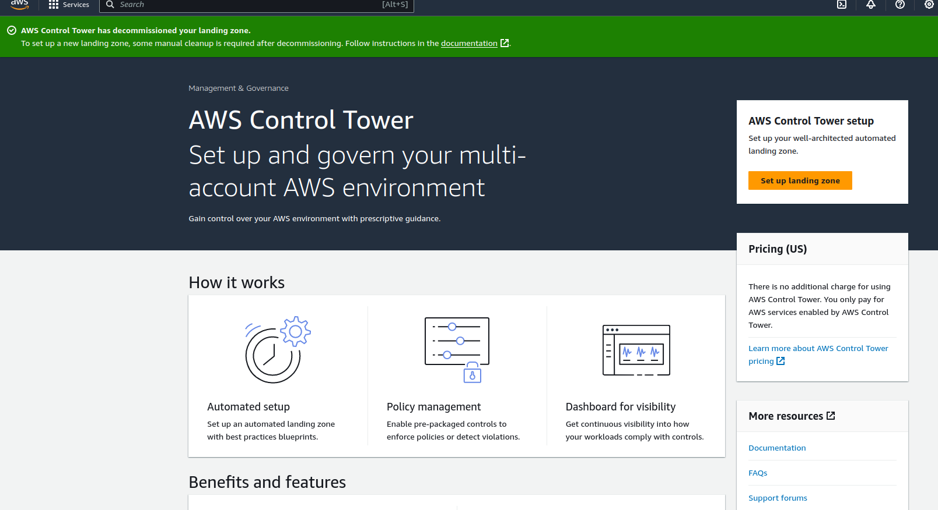
ARCHITECTURE DIAGRAM:
